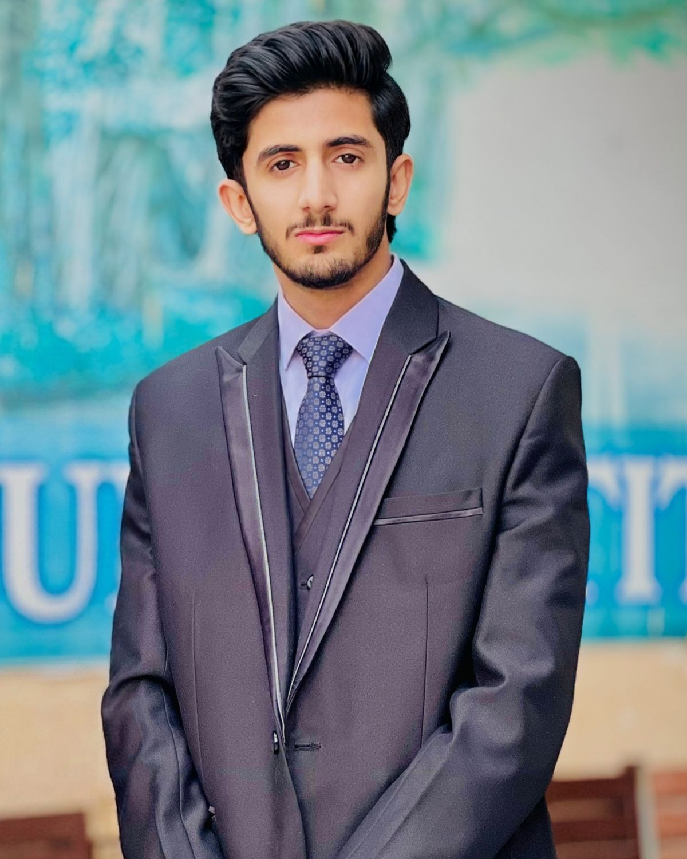  Contact  Mandi Bahauddin, Pakistan  +92 308 6779567  mahartayyab57@gmail.com  Skills  • Content Writing  • Research & Citation  • Scriptwriting  • CV / Resume Writing  • Basic Video Editing  • AI-Assisted Content Tools (Flow, Runway, Sora)  • MS Excel  • Basic Web Scraping  Languages  Urdu — Native  English — Professional  Education  Doctor of Pharmacy (PharmD)  2nd Semester  University of the Punjab, Lahore | MUHAMMAD TAYYAB IQBAL  Content Writer & Freelance Creative  Profile  PharmD student with hands-on experience in research writing, professional content creation, and freelance client work. Comfortable adapting tone across academic, professional, and audience-facing formats. Skilled in AI-assisted content workflows including video generation, scriptwriting, and editing.  Relevant Experience  Freelance Writer & Content Creator — Self-Employed | Ongoing  • Authored a fully-cited research article for the SPARK Society Article Writing Competition 2026, comparing historical and religious sources using a structured analytical framework  • Wrote and produced short-form comedy scripts for an original social media content brand (Sabzi Wala Pharmacist), focused on audience-first, plain-language storytelling  • Delivered professional CV/resume writing for freelance clients, including tailored formatting for international job applications  Strengths  • Adapts writing tone for academic, professional, and casual/comedic audiences  • Structures long-form research into clear, readable arguments  • Comfortable working with AI-assisted content and editing tools  • Reliable under deadline pressure — prioritizes scope over rushed quality

